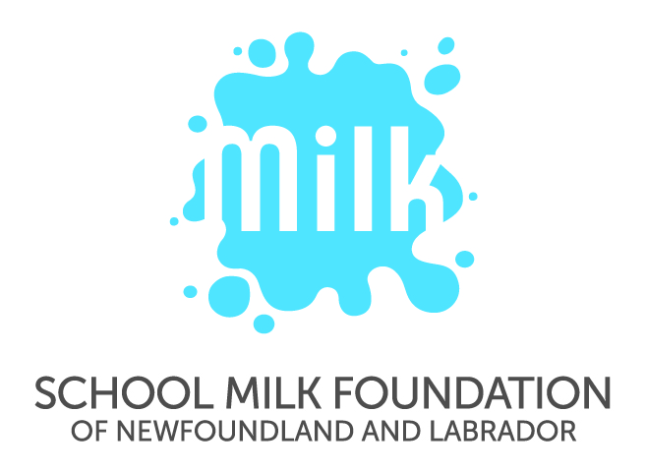
School Milk Foundation of Newfoundland and Labrador (SMF)
Milk It for School Spirit Social Media Promotion

OFFICIAL CONTEST RULES

Entries must adhere to the Social Media Use policy and terms of use established by the Newfoundland and Labrador English School District FIN-502 Social Media Use and FIN-502 Student Terms of Reference.

- ELIGIBILITY: To be eligible to enter and win a Prize, you must be a student, parent of a student, teacher, and/or staff member within the Newfoundland and Labrador English School District.

- HOW TO ENTER:
  - Eligible photos uploaded to SMF’s Facebook, Twitter and/or Instagram accounts during the Contest Period are automatically entered. Eligible photos must include the @SchoolMilkNL tag, the challenge #hashtag and a school #hashtag.
  - Individuals under the age of 16 are required to seek parental permission before posting photos of themselves and/or others.
  - Submissions must not contain photos of other students, teachers or district staff that have been taken without their knowledge or permission.
  - Participants are reminded to regularly check social media privacy settings to ensure photos and personal information is only available to those for whom the information is intended.
  - Entries made by students during class time will not be accepted.

- PRIZES:
  - There is one prize (Macbook Air) available to be won per challenge.
  - The odds of winning a prize in the Contest will depend upon the number of eligible Entries received during the Contest Period.
  - Prizes are awarded by random draw from entries received and/or entries that receive the most engagement (likes/comments/shares combined).

- PRIZE CLAIM(S): To be declared a winner of a Prize, you will be required to:
  - State your name, school, mailing address and date of birth.
  - Complete and return a Release of Liability form. If a winner is under the age of 16, a parent/guardian will be required to complete the Release of Liability form.

- RELEASES, ETC.: Before being declared a winner of a Prize, a selected entrant will be required to sign a Release of Liability form, which (among other things): (i) confirms compliance with these Official Contest Rules; (ii) acknowledges acceptance of the applicable Prize as awarded; (iii) releases the Sponsor, its advertising and promotional agencies, parent companies and affiliates of the foregoing and all of their respective directors, officers, owners, partners, employees, agents, representatives, successors and assigns (collectively, the “Releasees”) from any and all liability in connection with this Contest, (iv) agrees to the publication, reproduction and/or other use of his/her name, school, statements about the Contest and/or photograph or other likeness without further notice or compensation, in any publicity or advertisement carried out by or on behalf of the Sponsor in any manner whatsoever, including print or the internet. If a winner is under the age of 16, a parent/guardian will be required to provide written consent.

- PERSONAL INFORMATION:
  - By entering this Contest and submitting a photo, entrants agree to the publication, reproduction and/or other use of their name and school without further notice or compensation, in any publicity or advertisement carried out by or on behalf of the Sponsor in any manner whatsoever, including print or the internet.
  - If an entrants’ photo is chosen to be featured, this does not deem the entrant a contest winner.
  - By entering this Contest, entrants consent to the collection, use and disclosure of their personal information for the purposes of administering the Contest.
  - Submitted photos will be housed on School Milk Foundation’s internal database and social media platforms for one year. Entries may be used for promotional purposes.
  - By accepting a Prize, winners consent to the collection, use and disclosure to the public of their names, school, statements and photographs or other likenesses for publicity purposes in connection with the Contest in any media or formats including, but not limited to, the Internet, without further notice, permission or compensation. Personal information will not otherwise be used or disclosed without consent.

- LIMITATIONS OF LIABILITY: Without limiting the limitations of liability set forth elsewhere in these Official Contest Rules and Release of Liability, and for greater certainty, the Releasees will not be liable for: a) any incomplete or inaccurate information, b) any typographical or other errors in the offer or administration of this Contest, including but not limited to errors in advertising, these Official Contest Rules, the selection (if applicable) and/or announcement of eligible winner(s), and/or the distribution of any Prize(s); and/or e) any combination of the above.

- RIGHT TO TERMINATE, SUSPEND OR AMEND: Sponsor reserves the right to terminate, amend or suspend this Contest, in whole or in part, without prior notice.

- MISCELLANEOUS: Claimants who have not complied with these Official Contest Rules are subject to disqualification from this Contest. All decisions of Sponsor are final and binding without right of appeal in all matters relating to this Contest. The Releasees will not be responsible for illegible, incomplete, lost, misdirected or late Prize claims, all of which will be void. Contest is subject to all applicable federal, provincial and municipal laws.

For more information, please contact Jessica Murphy at (709) 364-2776 or jmurphy@schoolmilkfdn.nf.net.

